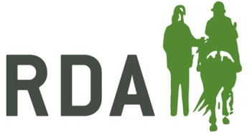
SAFEGUARDING REPORTING PROCEDURES
Reported or Suspected Abuse
If you suspect a child or adult at risk is being abused, they confide in you or someone has a concern, complaint or allegation about a member of staff, a volunteer or about you, it is your duty to report it. This is also the case if declarations are made to an RDA volunteer/ staff member about possible poor practice or abuse, even if there is no connection with RDA.
If an individual is at immediate risk to life call 999 and request the police, or if the individual is at risk of significant harm phone Social Services.
If a child or adult at risk has told you they are being abused, you must:
- Allow the individual to speak without interruption, accepting what is said.

- Explain that you cannot keep the information secret and must pass it on. If the disclosure is made by an adult, you must ask their consent to pass the information on.

- Inform the Group Safeguarding Officer immediately; disclosures are confidential and should only be shared by exception.

- Should the Group Safeguarding Officer not be available, the person who received the disclosure should contact the RDA Safeguarding Lead at RDA National Office directly or speak to their Group Chair.

- Write down what was said as soon as you can, using the actual words spoken to you. This includes the date & time, and then sign the document.

Concern for Someone’s Welfare
If you are concerned about the welfare of an RDA participant or volunteer, or you have concerns about the conduct/poor practise of an adult involved in RDA, including yourself, you must:
- Inform your Group Safeguarding Officer immediately

- If possible, write down what you have witnessed; include the date & time, and sign the document. Pass any notes you have made to the Group Safeguarding Officer
If you need further support or are not sure what you should do, you can contact:
RDA National Office: 01926 492915
RDA Safeguarding Out of hours: 07599 236036
NSPCC: 0808 800 5000

